Training Guru - T-CA1 Pitch #2

### What is our App? - One Sentence

Training Guru is an app that provides the bridge between Personal Trainers and their Clients.

### More in-depth description.

Personal Trainers can create custom workouts for their Clients which can be tracked through smart technologies and displayed on the training dashboard.

### Who is our App for?

Personal Trainers

### Why do they need this App?

Removes the need for check in meetings as both parties have all the up to date progress and feedback on goals

### Main Features:

### True Coach Features:

* Workout Builder - Allows coaches to create custom workouts and upload videos to a workout
* Video Library - True coach comes with its own video library with over 1000 premium workout videos
* Email Notifications - Automatically notify employees of upcoming workouts
* Progress Builder - Create one workout program and make minor adjustments for other users
* Progress Tracking - Track exercise history and metrics . Log Results goals, Nutrition
* Nutrition Tracking Assign macro goals nd you can track macro intake
* Compliance Rate: 7day, 90 day compliance rate . The number of workouts completed vs number of workouts assigned
* Dashboard:
* 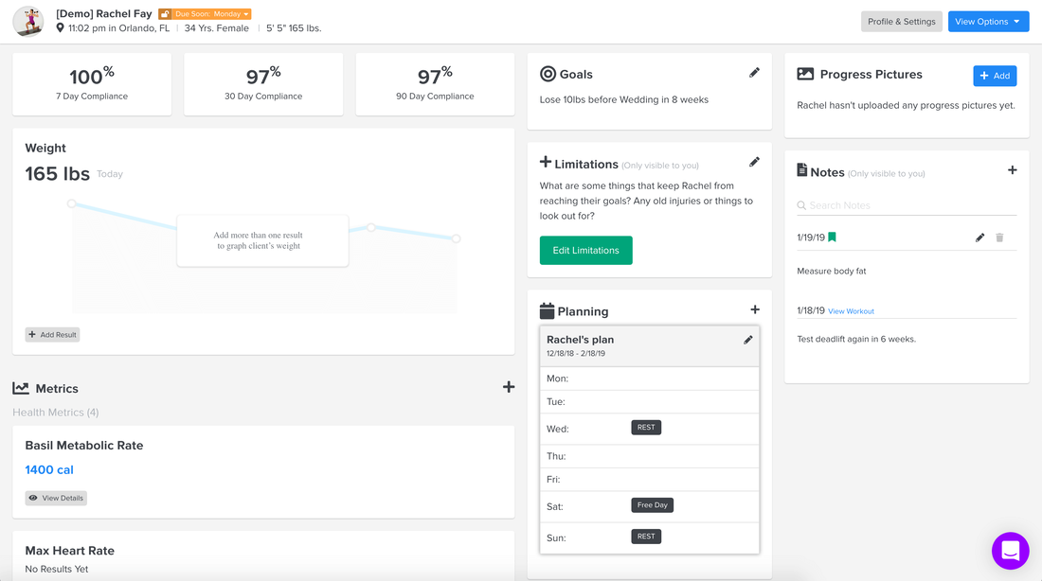

### Competitors - Differentiation?

* Can assign workouts to a client so if the Trainer as the client doing the same gym workout the work is created once and signed to many clients.(Dont have to create the same work out multiply times for different clients).
* Customizable Dashboards for the Personal Trainer.
* Calorie Tracking.

### Is Smart Technologies necessary?

No, but provides extra functionality - steps and calories

Can still have manual input but keeps app seamless and more user friendly, less time consuming, truthful

### Do you need a PT or can Users have their own account?

Glorified Diary to track workouts and progress

### What data will we have/store?

Workout summaries, daily/weekly steps, step goals, calories burnt, workout intensity, heart rate, sleep and stress levels. Calories consumed, macros consumed, calorie goals

### What will the database look like?

Tables: PT, Clients, Workouts, Client Calories, Past Sessions

### External Collaborators

Existing collaborators - Kyle McGee (DkIT), Rory Foster, Calum Moore

New Collaborators - Peadar Hughes, Physio in Hospital, Nutritionist, Manager of Football Team

A client approaches pt wants to lose wa=eight

Pt signs up clients

Send client login

Client logs in see workouts]

Pt sets goals

Client sees weekly/overall goals

After a week/month looks at dashboard see progress

Client hasnt lost weight - why?

Didnt hit steps/calories/sleep

Adapt program

Weekly checkin

AI - predicted change for goals - steps

Alternative foods - dont eat bread everyday

Initial Quiz - what the pt needs to know

Goals, activity level, current weight, height, picture?, etc…. Ask collaborators

Team Workouts

Application Form - <https://docs.google.com/forms/d/1h-R574XDa0qDFQEYOLSNa91I86r_8seb7bBIQD68Y1k/viewform?fbclid=PAAaZz847dJYmGx4aiRxrdcCy13Qhrp2b6bbLp5nqAn_4QHRGLDUdPJ5LZc4A&edit_requested=true>

Check In Form - <https://docs.google.com/forms/d/1HGb9Snf5GlN6X30z-qALdqpz5eCkL-WatJIs4EnbJxQ/viewform?edit_requested=true>